



Essay / Assignment Title: Database System Design for a Library

Programme title:

Name:

Year:

CONTENTS

INTRODUCTION 1
Project Overview 1
Role of Database Systems in the Administration of Library Activities 1
CHAPTER ONE: STORY OF THE LIBRARY 2
Background of the Library 2
Daily Running and Major Activities 2
Stakeholders Involved 3
CHAPTER TWO: ENTITY DESCRIPTION AND ER DIAGRAM 4
Entity Description 4
ER Diagram 5
Justification of Design 6
CHAPTER THREE: DATABASE IMPLEMENTATION 8
Schema Definition 8
SQL Scripts for Table Creation and Relationship Definition 8
Explanation of Tables and Relationships 10
Sample Data 12
Explanation of Sample Data: 16
CHAPTER FOUR: SQL QUERIES AND SCENARIOS 17
Simple Queries 17
Complex Queries 20
CHAPTER FIVE: ACCURACY AND CONSISTENCY OF THE DATABASE 24
Data Accuracy 24
Data Consistency 24
Challenges and Solutions 25
CONCLUDING REMARKS 26
Summary of the Project and Key Findings 26
Potential Future Improvements and Extensions 26
BIBLIOGRAPHY 27

Statement of compliance with academic ethics and the avoidance of plagiarism

I honestly declare that this dissertation is entirely my own work and none of its part has been copied from printed or electronic sources, translated from foreign sources and reproduced from essays of other researchers or students. Wherever I have been based on ideas or other people texts I clearly declare it through the good use of references following academic ethics.
(In the case that is proved that part of the essay does not constitute an original work, but a copy of an already published essay or from another source, the student will be expelled permanently from the postgraduate program).

Name and Surname (Capital letters):

.......................................................................................................................................

Date: ........................./........../.........

INTRODUCTION

Project Overview
This project focuses on the design and development of an efficient database management system for a public library using MYSQL technology. The main specific goals include ensuring that the library has a solid foundation and system that can support the lending of books, cataloging, as well as member administration. Through the successful completion of this project, the goal is to supplement theoretical knowledge with practice and solidify concepts learned, such as the CAP theorem in the context of database systems, by designing and implementing a database, writing advanced SQL queries, and the like.

Role of Database Systems in the Administration of Library Activities
Database systems are essential in handling library processes because they facilitate efficient storage, retrieval, and organization of large data. These facilitate in collecting data about books, members, loans, and staffs and maintain accuracy and uniformity of data. Database systems help in managing the different tasks involved in library functions more efficiently and in a shorter time span; they also contribute to enhancing the quality of decisions and the satisfaction of both library staff and users.

CHAPTER ONE: STORY OF THE LIBRARY

Background of the Library
The public library being analyzed for this case is a mid-sized library situated in a densely populated region in a large city. It contains numerous publications of more than 50 000 copies that can be classified as fiction, non-fiction, academic literature, children’s books, periodicals etc. The library has a membership of about ten thousand members who are students, professionals and dedicated readers in the community.

Daily Running and Major Activities
The library is opened during weekdays only and offers necessary services to its clientele. Key functionalities include:
Book Lending and Returning: You can lend books to members according to the agreed duration and the specific time when the books should be returned. This is done by implementing an organized procedure where loans and returns are recorded to ensure that all books are returned to the library to be borrowed by other members.
Cataloging: Some of the activities include purchasing of new books which is carried out frequently. Cataloging entails barcoding, shelving, and informing the library database about any stock acquisition.
Member Management: This database keeps records about the library’s members and their ID cards, borrowing records, and membership details. This aids in rendering customized services as well as the realization of the organizational goals and objectives.
Activity and Event Management: Often, the library hosts events such as reading sessions, meetings with authors, and informative workshops. These activities are coordinated and marketed with the aim of reaching out the community and popularizing reading culture.
Resource Management: Another important daily process is the controlling of the physical and information flows of the library. This includes shelving as well as preservation of the physical collection, management of other media resources and handling of journals and e-books’ subscriptions.

Stakeholders Involved
Librarians: The user charge with being in charge of the staff members of the library; it is their duty to address individuals, new acquisitions of books and the arrangement of the library as well.
Members: It can be defined as the users of given library’s facilities, the borrowers, the guests of various programs and the active participants in the readers’ community.
Administrators: This fully responsible executive team is responsible for the formulation of strategies, resource mobilization, budgeting and overall administration of the library. They make sure that the established goals and objectives are achieved so that the library can effectively cover the demands of the society.
Support Staff: Workers who help in shelving of books and keeping the facility in order, planning of various activities, management of the compound, and handling of various technical aspects including the library information systems.
This chapter gives an introduction on environment of the library and specifies the size and the functioning of the library and other stakeholders involved in the running of the library (Arndt et al., 2021). This framework creates the background for the subsequent chapters, which will discuss the proposed design and development of a proficient database system that can improve the functionality of the library.

CHAPTER TWO: ENTITY DESCRIPTION AND ER DIAGRAM

Entity Description
In developing the database system for the public library, several critical entities have been identified that encapsulate the core aspects of its operations (Iqbal et al., 2023):
1. Books:
Attributes
- ID,
- ISBN,
- Title of book,
- Author of the book,
- Publisher,
- Year of publication,
- GenreID
- Availability.
Significance: Serves as a reference to each book in library collection, in addition to aiding in the shelving, record-keeping, and conducting of all the book-related business like lending and overdue books.
2. Members:
Attributes
- MemberID,
- Name,
- Address,
- Contact Number,
- Email,
- Membership Type,
- Joining Date
- StaffID.
Significance: Completed forms which contain the details of the members and this are used to organize library services, borrowing record and memberships.
3. Loans:
Attributes
- LoanID,
- BookID,
- MemberID,
- Issue date,
- Return date,
- Status.
- StaffID
Significance: Documents borrowing activities of members, assigns out individual books to members for a given period. This entity also makes sure that the process of book circulation will run smoothly and can track the situation when needed.
4. Staff:
Attributes:
- StaffID,
- Name,
- Role,
- Contact Information.
Significance: Provides documentation for the library staff, overlooks staff matters, members’ assignments, and rightful claims to responsibilities within the library.
5. Genres
Attributes
- GenreID
- GenreName
Significance: Categorizes books based on their genres, aiding in organization and search ability. This helps patrons find books of interest and assists the library in maintaining a diverse and organized collection.
6. BookStaff
Attributes:
- BookID
- StaffID
Significance: Represents the relationship between books and staff members. This helps in tracking which staff member is responsible for which books, assisting in accountability and management of the library’s collection.

ER Diagram
Entity-Relationship (ER) diagram is a type of graphical representation that depicts how entities in a database interrelate. It makes use of symbols to represent entities such as tables, attributes, relationships, and cardinalities. ER diagrams are crucial for:
1. Visual Clarity: Explaining and demonstrating structures as well as relations within databases.
2. Database Design: Helping in developing tables and relations.
3. Communication: Creating meaning among stake holders.
4. Normalization: Contributes to eradication of duplicate data storage.
5. Planning and Documentation: Participating in implementing databases and documenting the results.

The relationships in the ER diagram can be titled as follows:
Books (1) --- (M) Loans: A book can be borrowed by many members at one time or different time which points to one and many example.
Members (1) --- (M) Loans: A member can borrow many books, but many books borrowed are linked to the member, hence the one to many relationship between a member and books borrowed.
Staff (1) --- (M) Loans: Staff members control the loan activity, and each loan is related to the staff member who entered it, so the relationship is one-to-many.
Cardinality is also included in the ER diagram in order to show the type of the connection between the entities in order to provide understanding on the flow and interactions of data within the system.
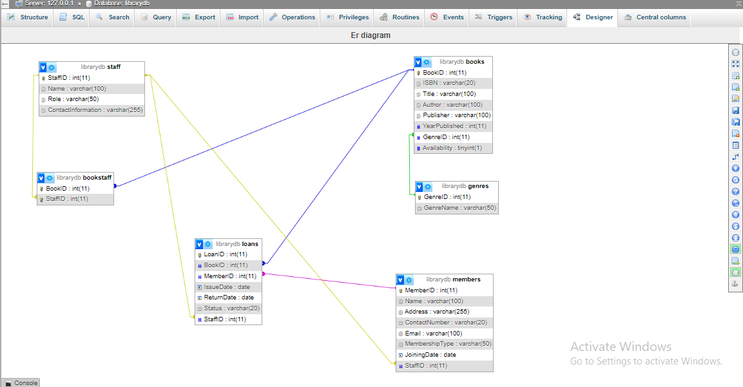
Title: Entity-Relationship (ER) Diagram of the Library Database System

Justification of Design
Their design choices are driven by the following considerations:
Efficiency and Performance: By structuring the database around these entities, the data you need to obtain and the processes you need to perform are easy to manage. For instance, when using normalized tables, there is little repetition of information and all records have similar data.
Scalability: This is due to the fact that the design provides for future growth of the system by permitting the creation of more book records, membership records, and staff records while maintaining efficiency and accuracy of the system.
User-Centric Approach: The prioritization of other entities such as Books and Members leads to better service delivery to clients and improved management of the library resources, hence improving satisfaction levels among the user and internal operational efficiency.
The selected entities and their characteristics are carefully chosen to reflect the requirements of functioning in the library to help the database system run efficiently in book circulation, member services, and staff services. These conceptual designs will then be implemented in the following MySQL tables and relationships during the implementation phase discussed in the following chapter.

CHAPTER THREE: DATABASE IMPLEMENTATION

Schema Definition
When developing the structure of the databases to be used in the public library, SQL Scripts have been made to create tables as well as cross refer them. Inclusive of every table, right columns, proper data type, and constraints that will facilitate proper receipt and treatment of collected data.

SQL Scripts for Table Creation and Relationship Definition
```sql
-- Database: LibraryDB
CREATE DATABASE LibraryDB;
USE LibraryDB;

-- Table: Genres
CREATE TABLE Genres (
GenreID INT PRIMARY KEY,
GenreName VARCHAR(50) NOT NULL
);

-- Table: Staff
CREATE TABLE Staff (
StaffID INT PRIMARY KEY,
Name VARCHAR(100) NOT NULL,
Role VARCHAR(50),
ContactInformation VARCHAR(255)
);

-- Table: Books
CREATE TABLE Books (
BookID INT PRIMARY KEY,
ISBN VARCHAR(20) NOT NULL,
Title VARCHAR(100) NOT NULL,
Author VARCHAR(100),
Publisher VARCHAR(100),
YearPublished INT,
GenreID INT,
Availability BOOLEAN DEFAULT TRUE,
FOREIGN KEY (GenreID) REFERENCES Genres(GenreID)
);

-- Table: Members
CREATE TABLE Members (
MemberID INT PRIMARY KEY,
Name VARCHAR(100) NOT NULL,
Address VARCHAR(255),
ContactNumber VARCHAR(20),
Email VARCHAR(100),
MembershipType VARCHAR(50),
JoiningDate DATE,
StaffID INT,
FOREIGN KEY (StaffID) REFERENCES Staff(StaffID)
);

-- Table: Loans
CREATE TABLE Loans (
LoanID INT PRIMARY KEY,
BookID INT,
MemberID INT,
IssueDate DATE,
ReturnDate DATE,
Status VARCHAR(20),
StaffID INT,
FOREIGN KEY (BookID) REFERENCES Books(BookID),
FOREIGN KEY (MemberID) REFERENCES Members(MemberID),
FOREIGN KEY (StaffID) REFERENCES Staff(StaffID)
);

-- Table: BookStaff
CREATE TABLE BookStaff (
BookID INT,
StaffID INT,
FOREIGN KEY (BookID) REFERENCES Books(BookID),
FOREIGN KEY (StaffID) REFERENCES Staff(StaffID),
PRIMARY KEY (BookID, StaffID)
);
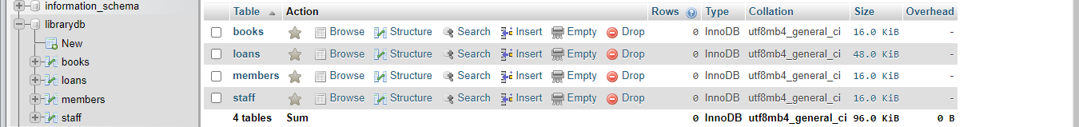
Title: Tables created in the MySQL database for the library system

Explanation of Tables and Relationships
1. Books Table: Holds details on each book in the library such as the ID given to it, the title of the book, author, call number, subject and any other information the user wants to input regarding the book. The fields are as follows:
- BookID (identifying number for each record)
- ISBN
- Title
- Author
- Publisher
- Year pub
- Genre, and
- Availability.
Regarding book status, the Availability column allows the librarian, among other things, to indicate whether the book is available for borrowing at the present moment.
2. Members Table: Keeps records of those who are associated with the library in one way or the other. These are:
- MemberID (part standing as key)
- Name
- Address
- ContactNumber
- Email
- MembershipType and
- JoiningDate.
3. Loans Table: Records loans extended by members of society. They include:
- LoanID (identity field),
- BookID (foreign to the Book table),
- MemberID (foreign to the Member table),
- IssueDate
- ReturnDate and
- Status.
Foreign key constraints are used with the intent of managing data integrity and are related to connecting books to loans and members appropriately.
4. Staff Table: Document purpose: Collects information regarding employees in a library. The table consists of
- StaffID (numeric, auto number type primary key),
- Name,
- Role,
- ContactInformation.

Sample Data
To show how the database system works, actual data has been introduced in each of the tables despite of the fact that they are only samples and represents the situations that may occur in a library.
Sample Data Insertion:

```sql
-- Sample data for Books table
INSERT INTO Books (BookID, ISBN, Title, Author, Publisher, YearPublished, Genre, Availability)
VALUES
(1, '978-3-16-148410-0', 'The Catcher in the Rye', 'J.D. Salinger', 'Little, Brown and Company', 1951, 'Fiction', true),
(2, '978-0-13-449416-6', 'Database System Concepts', 'Abraham Silberschatz, Henry F. Korth, S. Sudarshan', 'McGraw-Hill Education', 2019, 'Computer Science', true),
(3, '978-0-545-17611-2', 'Diary of a Wimpy Kid: The Meltdown', 'Jeff Kinney', 'Amulet Books', 2018, 'Children''s Fiction', true);
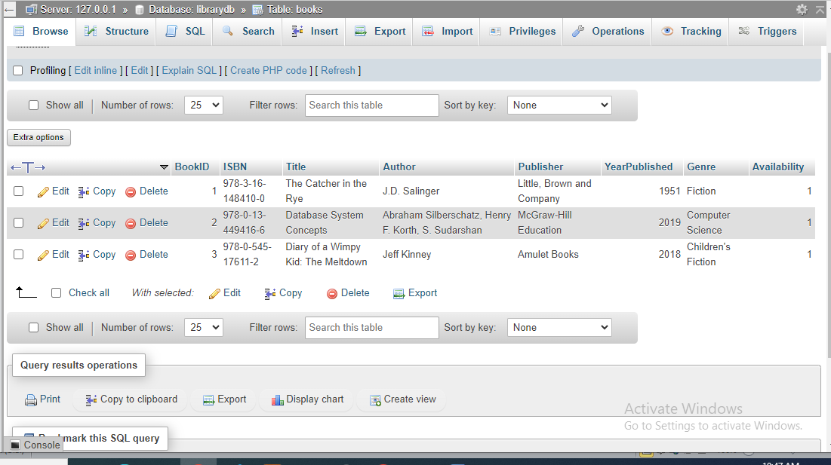
Title: Books Table Schema in MySQL

-- Sample data for Members table
INSERT INTO Members (MemberID, Name, Address, ContactNumber, Email, MembershipType, JoiningDate)
VALUES
(101, 'John Doe', '123 Main St, Anytown', '+1-234-567-8901', 'john.doe@example.com', 'Premium', '2020-01-15'),
(102, 'Jane Smith', '456 Elm St, Othertown', '+1-345-678-9012', 'jane.smith@example.com', 'Standard', '2020-02-20');
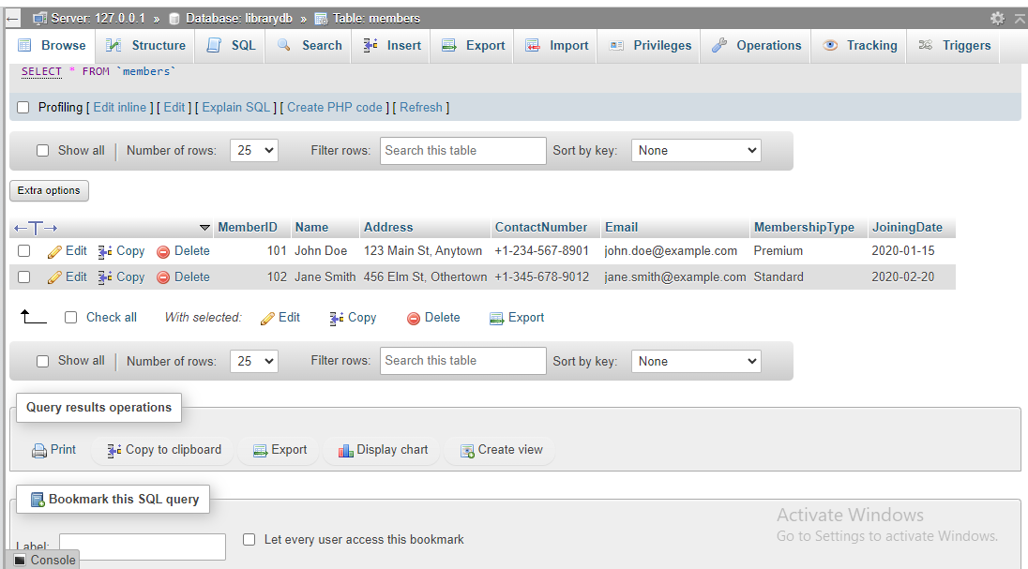
Title: Members Table Schema in MySQL
-- Sample data for Loans table
INSERT INTO Loans (LoanID, BookID, MemberID, IssueDate, ReturnDate, Status)
VALUES
(1, 1, 101, '2020-02-01', '2020-02-15', 'Returned'),
(2, 2, 102, '2020-03-10', '2020-03-25', 'On Loan'),
(3, 3, 101, '2020-04-05', NULL, 'On Loan');

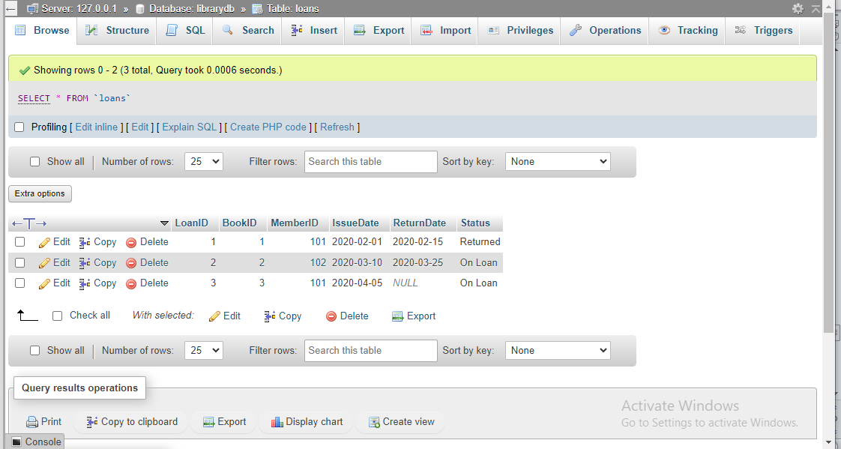
Title: Loans Table Schema in MySQL

-- Sample data for Staff table
INSERT INTO Staff (StaffID, Name, Role, ContactInformation)
VALUES
(201, 'Emily Brown', 'Librarian', '+1-456-789-0123'),
(202, 'Michael Johnson', 'Library Assistant', '+1-567-890-1234');
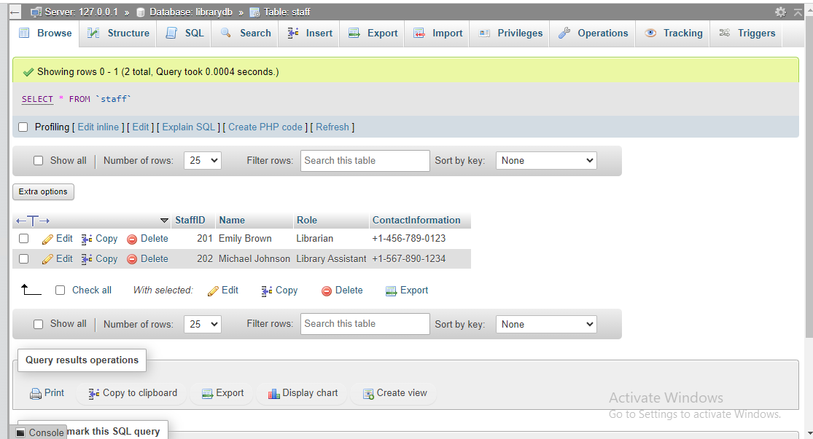
Title: Staff Table Schema in MySQL

Explanation of Sample Data:
A sample Books data populated into the table consists of books from various categories, which are popular. In the Members table, for example there are two fictional members namely John Doe and Jane Smith of the following membership, respectively. The data of Loans table contains records of borrowing books by members and status of the loans (e.g. “Returned,” “On Loan”). An example of a staff table entry indicates the staff and the position occupied and the contact details as well.
This chapter intent to offer an exposé of the used database schema, where details about table creation using SQL scripts are given, as well as a table by table description of the used schema and lastly, sample data to portray the standard library situations. The implementation phase guarantees that the organized database system captures the operational resembles the public library and be able to manage books, members, loans, and staff.

CHAPTER FOUR: SQL QUERIES AND SCENARIOS

This chapter presents an example of how SQL queries work with the library database, which includes basic and advanced query examples. There is a common scenario and SQL code for each query, as well as screenshots of the results of query execution (Bush, 2020).

Simple Queries
Query 1: Retrieve All Books
Scenario: The library staff wants to view a list of all the books available in the library.
SQL Code:
```sql
SELECT * FROM Books;
Title: Execution Result -Retrieve All Books Query Result
Query 2: Retrieve Member Details
Scenario: A report needs to be generated to show the details of all registered library members.
SQL Code:
```sql
SELECT * FROM Members;
Title: Execution Result -Retrieve Member Details Query Result
Query 3: Retrieve Available Books
Scenario: A member wants to know which books are currently available for borrowing.
SQL Code:
```sql
SELECT * FROM Books WHERE Availability = TRUE;
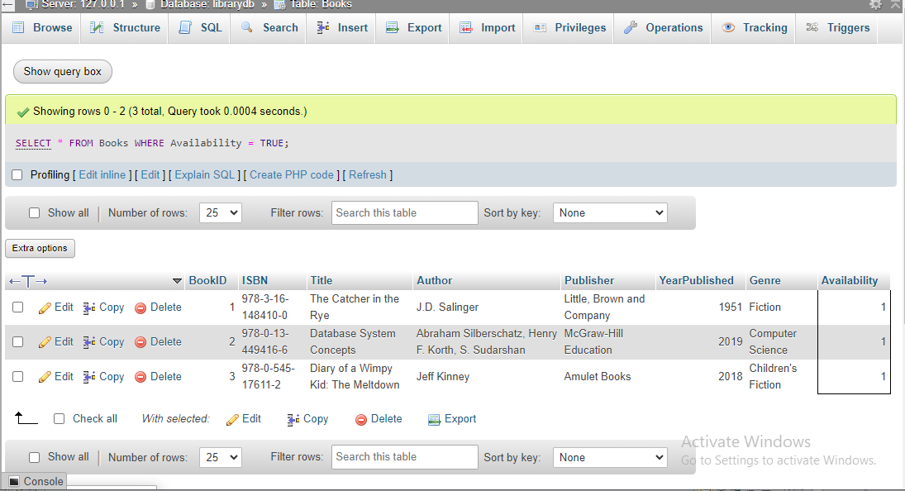
Title: Execution Result - Retrieve Available Books Query Result
Query 4: Retrieve Books by Genre
Scenario: A member is interested in finding all books in the 'Fiction' genre.
SQL Code:
```sql
SELECT * FROM Books WHERE Genre = 'Fiction';
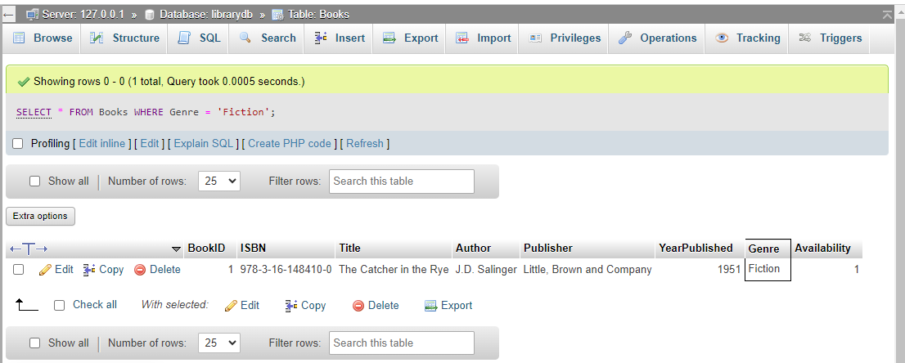
Title: Execution Result - Retrieve Books by Genre Query Result

Complex Queries
Query 1: Books Borrowed by a Specific Member
Scenario: The library staff needs to know which books have been borrowed by the member with MemberID 101.
SQL Code:
```sql
SELECT Books.Title, Loans.IssueDate, Loans.ReturnDate
FROM Loans
JOIN Books ON Loans.BookID = Books.BookID
WHERE Loans.MemberID = 101;
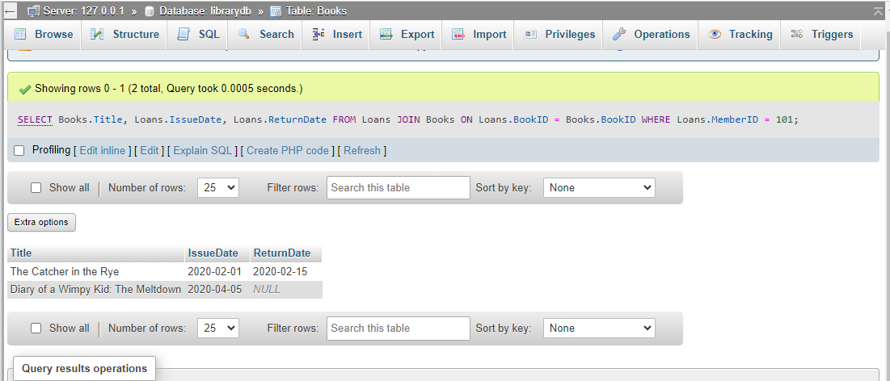
Title: Execution Result - Books Borrowed by a Specific Member Query Result
Query 2: Count of Books Borrowed by Each Member
Scenario: The library wants to generate a report showing the number of books borrowed by each member.
SQL Code:
```sql
SELECT Members.Name, COUNT(Loans.BookID) AS NumberOfBooksBorrowed
FROM Members
JOIN Loans ON Members.MemberID = Loans.MemberID
GROUP BY Members.Name;
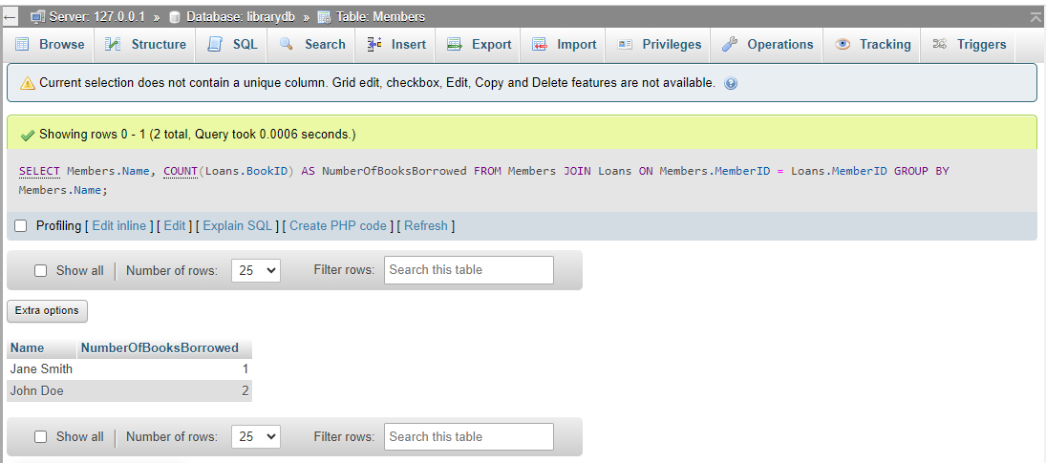
Title: Execution Result - Count of Books Borrowed by Each Member Query Result
Query 3: Overdue Books
Scenario: The library needs to identify all overdue books (assuming today’s date is '2020-04-15').
SQL Code:
```sql
SELECT Books.Title, Members.Name, Loans.IssueDate, Loans.ReturnDate
FROM Loans
JOIN Books ON Loans.BookID = Books.BookID
JOIN Members ON Loans.MemberID = Members.MemberID
WHERE Loans.ReturnDate < '2020-04-15' AND Loans.Status = 'On Loan';
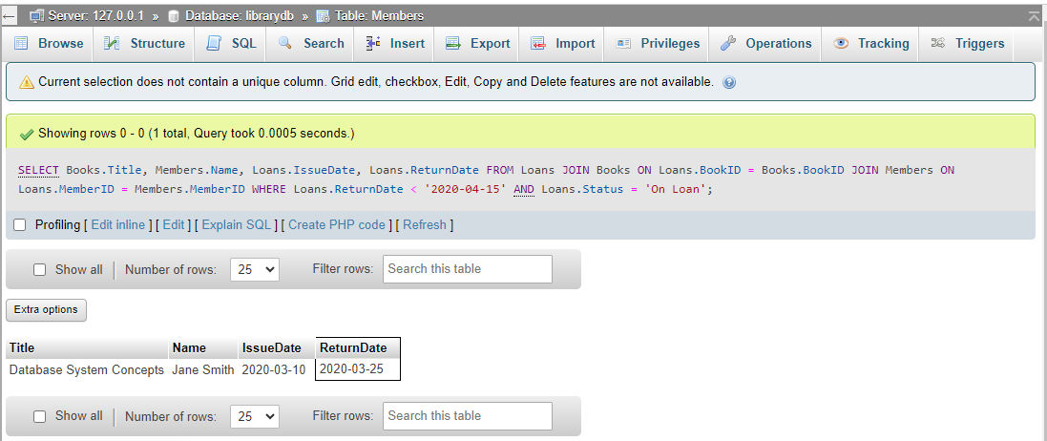
Title: Execution Result - Overdue Books Query Result
Query 4: Books and Their Borrowers
Scenario: The library staff wants to know who borrowed which books, including those that have been returned.
SQL Code:
```sql
SELECT Books.Title, Members.Name, Loans.IssueDate, Loans.ReturnDate, Loans.Status
FROM Loans
JOIN Books ON Loans.BookID = Books.BookID
JOIN Members ON Loans.MemberID = Members.MemberID;
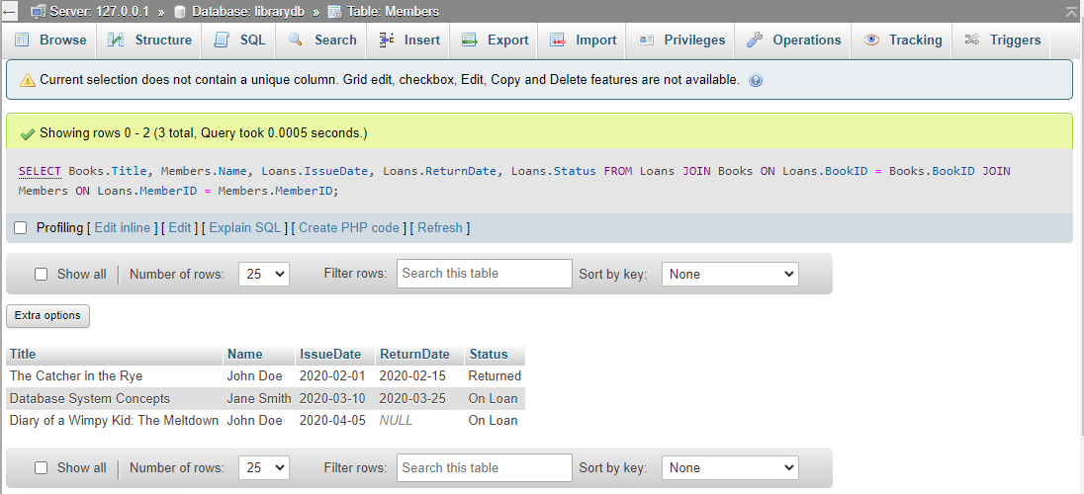
Title: Execution Result - Books and Their Borrowers Query Result
This chapter demonstrates how simple and complex selections and joins in SQL may help identify successful books, students, and library workflows in the large library, as well as contribute to management decision making.

CHAPTER FIVE: ACCURACY AND CONSISTENCY OF THE DATABASE

Data Accuracy
Methods to Ensure Data Accuracy
Data Validation: Applying data validation constraints to allow only meaningful values in the database and prevent the entry of incorrect values. For example, confirming that the `ISBN` of the book meets some format or the characters of the email are correct.
Constraints: Hence, applying constraints like `PRIMARY KEY`, `FOREIGN KEY`, `UNIQUE`, `NOT NULL`, and `CHECK` to enhance integrity and accuracy of data for example, the `PRIMARY KEY` constraint ensures that each book or member record has its unique identification number.
Examples of Data Accuracy
Books Table: To validate the `ISBN` field, it is checked whether it has the right format and length. In the `YearPublished` field, constraint ensures that the given year is reasonably plausible.
Members Table: The `Email` field is check for the correct format of an email address. The `ContactNumber` field checks that the entered phone number follows a certain pattern.

Data Consistency
Importance of Data Consistency
In a library setting, data consistency refers to the quality of the information that is stored about books, members, loans and staff in the library system (Lynch et al., 2021). Recurrent data contributes to the reliability of library procedures including lending and returning books, issuing and punishing members.
How the Database Design Supports Consistency
The database also maintains compliance with the ACID properties in relation to processing financial transactions. For instance, in a transaction for borrowing a book, the availability status of the book is updated correctly in all the relative tables.
Applying transactions to the complex operations, meaning, in case some of the operations of the transaction are completed, the others are completed as well. This avoids data issues and ensures that data is correct and up to date. For instance, the action of borrowing a book means updating the `Books` and `Loans` tables using a single transaction.

Challenges and Solutions
Users working concurrently on the database increases the chance of having problems with consistency. Preventions involve adequate control of transaction isolation levels and locking as a way of addressing the problem of concurrency.
Consequently, one has to deal with more than one copy of the data that could lead to inconsistencies. Data normalization is used in order to reduce redundancy by making sure that all data is placed in the correct table and related through keys.
Error Handling: Designing adequate control procedures for the purpose of controlling and addressing problems that may arise during transactions. This helps in avoiding a situation where an error has put the database to a wrong state.
This chapter underscores the need to deal with issues relating to data accuracy and consistency of the library database for fruitful working. If appropriately initiated and managed, it becomes possible to satisfy the library’s needs without compromising the database’s accuracy and reducing the possibility of errors.

CONCLUDING REMARKS

Summary of the Project and Key Findings
The purpose of this project was to design and enhance an effective database management system for a public library using MySQL (Tong and Nawi, 2022). Activities included developing the Entity-Relationship (ER) diagram, instantiation of the database schema, and coding of the SQL statements to illustrate usage of the database. Some of the important discoveries made are the need to create a good and reliable database structure that will be able to manage increased traffic and the practical use of concepts like the CAP theorem (Lee et al., 2021).

Potential Future Improvements and Extensions
Enhanced User Interface: Creating a graphical user interface specifically for library staff and members may help enhance the interaction with the databases and between the library books, members, and loans.
Automated Notifications: It would benefit the library user and the library to set up a notification system to warn users of due dates, overdue books, and events.
Advanced Analytics: The advanced analytics that will be incorporated for borrowing patterns, circulation of specific genres, and activities of the members can benefit the management of the library.
Scalability: The database system design must be ready for the future growth of the data and users in terms of scalability. This might include improving the efficiency of database operations and exploring the use of distributed databases.
In summary, the intended learning outcomes of the project have been met, and a strong framework has been laid for further projects in database systems and business analytics to be built upon.

BIBLIOGRAPHY

Arndt, D., Bangerth, W., Davydov, D., Heister, T., Heltai, L., Kronbichler, M., Maier, M., Pelteret, J.P., Turcksin, B. and Wells, D., 2021. The deal. II finite element library: Design, features, and insights. Computers & Mathematics with Applications, 81, pp.407-422.
Iqbal, A., Khan, S.U., Niazi, M., Humayun, M., Sama, N.U., Khan, A.A. and Ahmad, A., 2023. Advancing database security: a comprehensive systematic mapping study of potential challenges. Wireless Networks, pp.1-28.
Tong, Y.R. and Nawi, N.B.M., 2022. Library Management System. Applied Information Technology And Computer Science, 3(2), pp.1389-1402.
Lee, E.A., Bateni, S., Lin, S., Lohstroh, M. and Menard, C., 2021. Quantifying and generalizing the CAP theorem. arXiv preprint arXiv:2109.07771.
Lynch, R., Young, J.C., Jowaisas, C., Rothschild, C., Garrido, M., Sam, J. and Boakye-Achampong, S., 2021. Data challenges for public libraries: African perspectives and the social context of knowledge. Information Development, 37(2), pp.292-306.
Bush, J., 2020. Learn SQL Database Programming: Query and manipulate databases from popular relational database servers using SQL. Packt Publishing Ltd.

